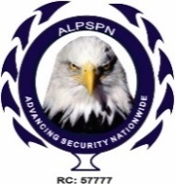Association of Licensed Private Security Practitioners of Nigeria
National Headquarters, Abuja.

INTERNAL MEMO
REF NO: ALPSPN/MEMO /VOL4/0558
From: General Secretary
To: Newly Licensed Companies
Date: 9th February, 2023
Subject: CONGRATULARTORY MESSAGE

Dear Professional Colleagues,

On behalf the Board of Trustees and the National Executive Council of the Association of Licensed Private Security Practitioners of Nigeria [ALPSPN]. I want to congratulate you once again as a fully licensed operator in the security Industry.
Sequel to the President’s presentation at the Inauguration ceremony held yesterday 8th February, 2023 at the National Headquarters of the Nigeria Security and Civil Defence Corps [NSCDC] on needs for all newly inaugurated members to be part of the Association.
Kindly liaise with your state chapter chairman for state registration and send the filled National membership form given to you at the event with the following documents;
- Photocopy of CAC
- Photocopy of License
- State teller and Receipt and your National Teller
- Two Passport Photograph each for the CEO and one Representative
Documents are to be submitted through DHL to our National Head office No 35 First Avenue, Kado Estate, Abuja. This in turn will help us process your membership certificate. For more information please send us a mail on alpsp@gmail.com.
I welcome you once again, looking forward to working with you to moving the Security Industry forward.
Accept my warmest regards.
Yours sincerely,
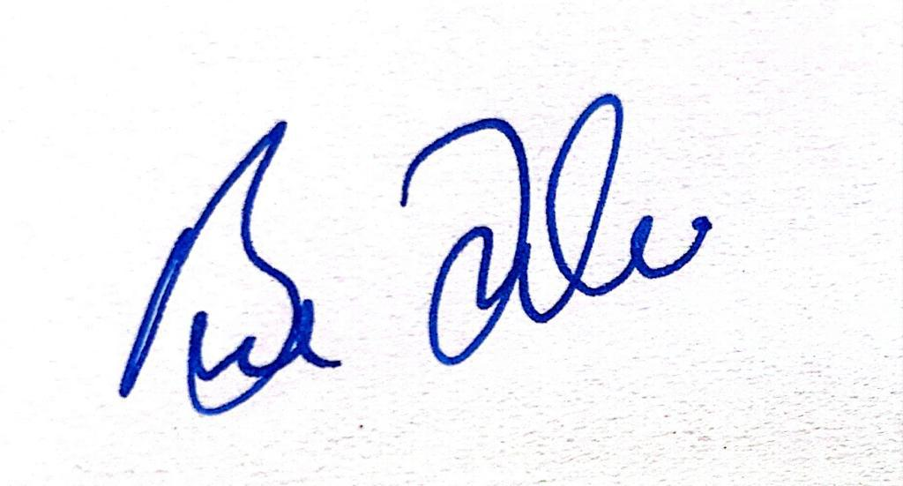
MRS BUDUKA J. ADDEY
NATIONAL GENERAL SECRETARY

